Data flow diagram-phase II

|  |  |
| --- | --- |
| Date | 10 Oct 2022 |
| Team ID | PNT2022TMID39226 |
| Project Name | Machine Learning based Vehicle Performance Analyser |
| Maximum Marks | 4 Marks |

**Data Flow Diagrams:**

A Data Flow Diagram is a traditional visual representation of the information flows within a system. A neat and clear DFD can depict the right amount of the system requirement graphically. It shows how data enters and leaves the system, what changes the information, and where data is stored.

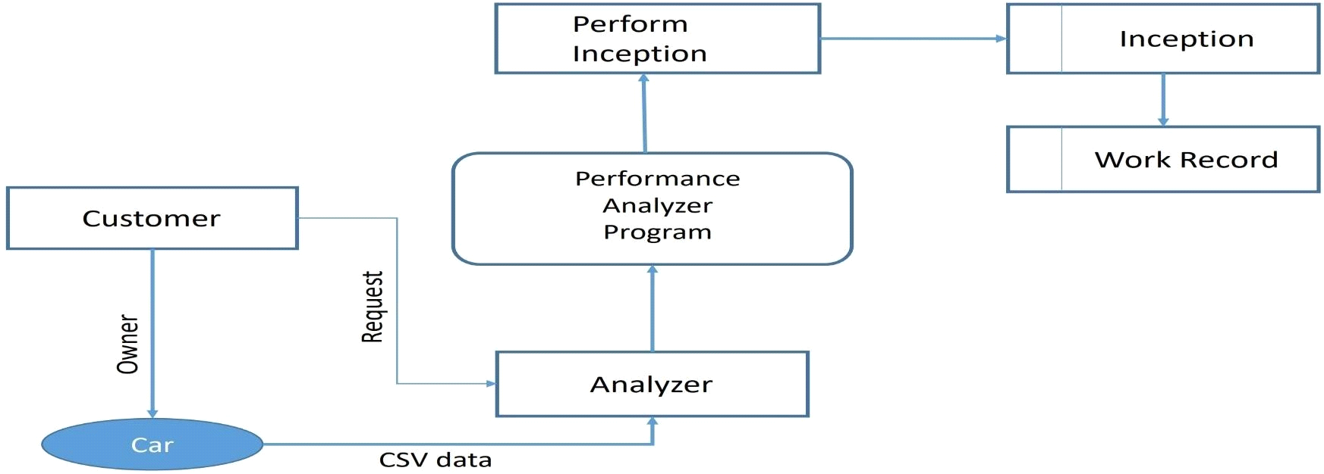

**User Stories**

Use the below template to list all the user stories for the product.

|  |  |  |  |  |  |  |
| --- | --- | --- | --- | --- | --- | --- |
| **User Type** | **Functional Requirement (Epic)** | **User Story Number** | **User Story / Task** | **Acceptance criteria** | **Priority** | **Release** |
| Customer | Access the webpage | USN-1 | As a user anyone can access the webpage to check the specifications of the vehicle. | I can access my web page through online at any time. | High | Sprint-1 |
| Customer | Performance of the vehicle | USN-2 | As per the usage of user the performance of the vehicle should be predicted easily. | Prediction can be done in easy way. | High | Sprint-2 |